Introduction

General
DICOM Sniffer is a GUI network protocol analyzer. It is the combination of Network sniffer and DICOM protocol analyzer. DICOM Sniffer 's native capture file format is libpcap format, which is also the format used by various other sniffer tools.

This application has the capability to:
- Sniff the live DICOM network stream.
- Save DICOM stream to a capture (.cap) file by filtering DICOM communication only between two IP addresses.
- Read cap files (saved network stream).
- Evaluate/validate DICOM communication in single/multiple DICOM association and display the overview and detail report in HTML format.
- Display Service element list and Association details per association.
- Saving the Service element (DICOM object) as DICOM (DCM) file.
- Storing/opening the current configuration/setting (.setup) files.
- Providing detailed activity logging with byte dump.

Software Requirements
  - The following operating systems are supported:
- Windows NT 4 SP6a
- Windows 2000 Professional
- Windows XP Professional

  - Microsoft .NET framework 1.1
- WinPCap 3.0 or above

See: http://www.dvtk.org for new versions and features.

Getting Started

Sniffing the live network
Start the application from start -> Programs -> DVTk -> DICOM Network Analyzer. The below screen shot shows the DICOM sniffer UI. This is the default ‘Capture’ mode. Set the IP address in IP2 text box, as you want to sniff between two nodes and press the ‘Start Capture’ button (Green triangle). User can stop capturing by pressing ‘Stop Capture’ (Red rectangle) button.
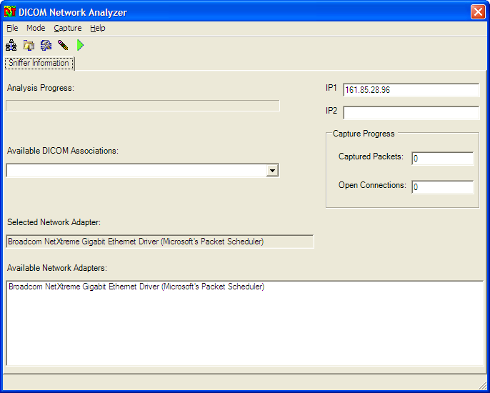

Note: User can view the live capture progress and perform the subsequent actions.

Saving DICOM live stream in a capture file
The communication sniffed by this tool between two DICOM nodes can be saved in a capture file as shown in the screen shot. The saved capture file will be in libpcap format and can be read by other standard tools e.g. Ethereal, Merge DPM etc.
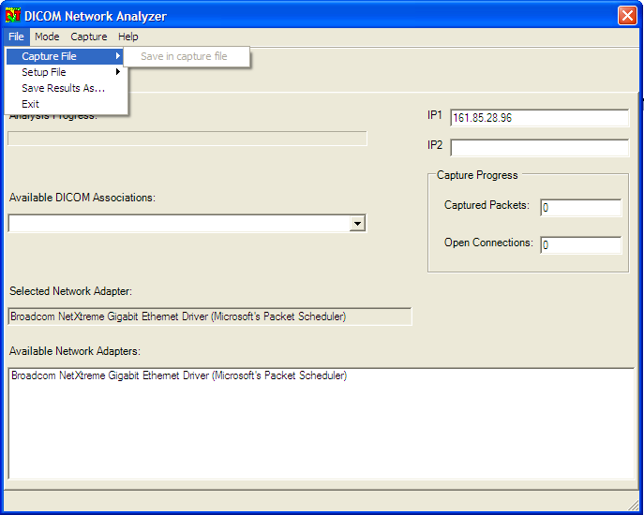

Reading capture files
This feature is available in ‘Analysis’ mode. Choose ‘Analysis’ mode for reading capture files (.cap). User can read the capture file by pressing ‘File Open’ icon or using File-> Capture File-> Load menu. User can view the analysis progress in progress bar. ‘Available DICOM Associations’ combo box will display list of DICOM associations. User can select particular association and view Association, PDUs details and Evaluation result on different tabs as shown in screen shot.
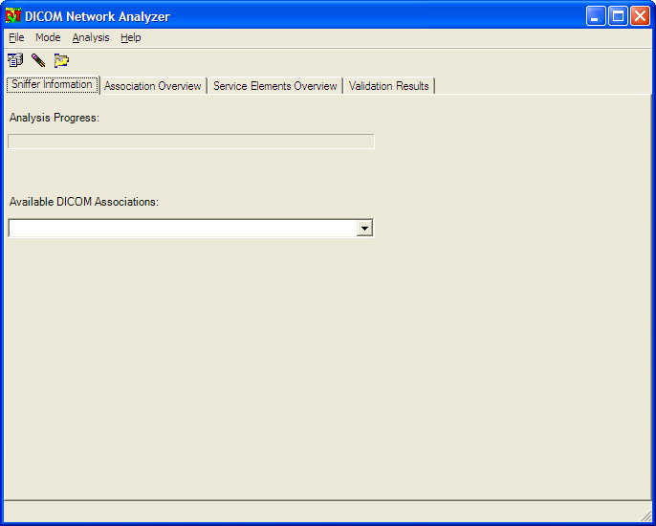

Evaluate and validate all DICOM communication in a cap file
Press Analysis-> Evaluate All DICOM Associations button and the application will evaluate and validate the DICOM communications in a capture file and provide the results in a DVTk logging (HTML) format on Validation Results tab. The application will not only display the overview/detail result report but also provides feedback about possible DICOM violations.

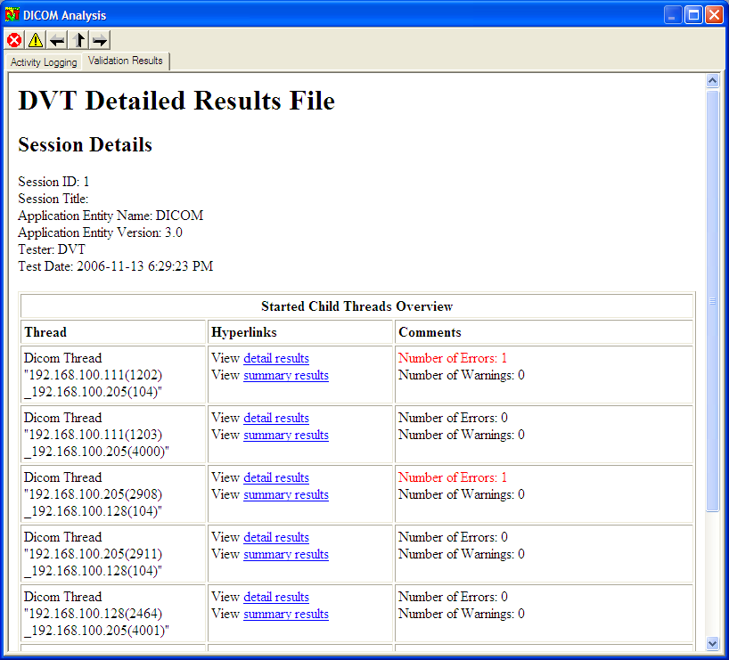

Saving the individual DIMSE (DICOM object)
During DICOM communication between two network nodes, the DICOM objects exchange takes place. All the service elements exchanged are displayed on the Service Elements Overview tab. The user can save the DIMSE (DICOM object) by right click the DIMSE and ‘Save As DCM File..’.

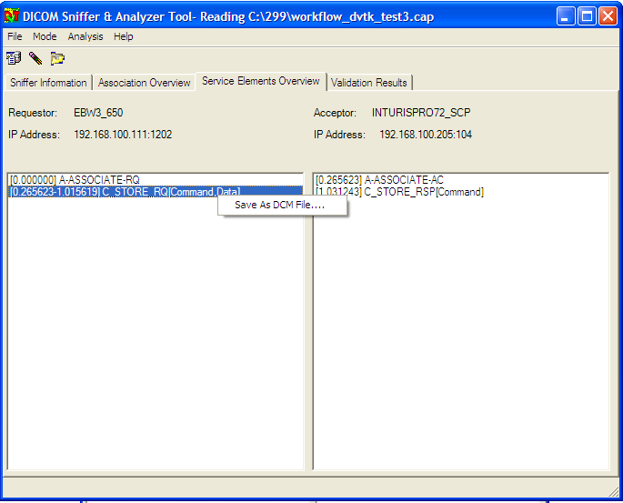

Note: ACSE can not be saved as DICOM object because this feature is not available for ACSE.

Storing/opening the configuration/setting (.setup) files
Users can load/save the current configuration/setup of the tool in setup files.
The setup file is a XML file and contains following settings:
- IP Addresses
- HTML Result Full File Name
- Activity Log Full File Name

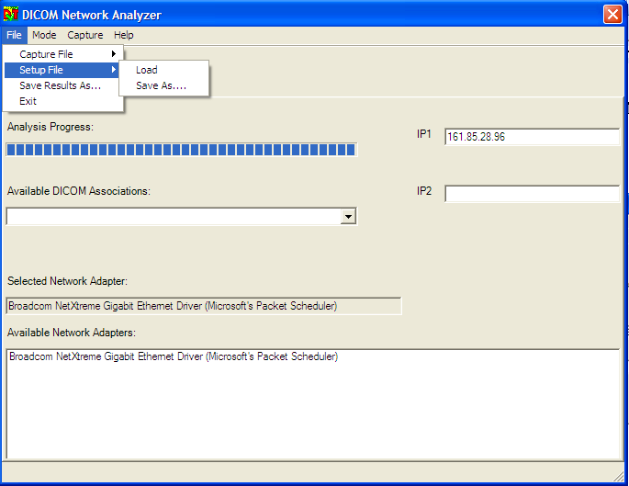

Providing detailed activity logging with byte dump
The ‘Activity Logging’ tab provides the detailed logging of DICOM communication and the entire PDUs dump. User can also view the byte dump if he sets the session property ‘PDU-DUMP’ to true.
The session property can be set manually by opening ‘Sniffer.ses’ file (application folder) in the notepad.

New Features in Sniffer

Improvement in UI look and feel
- Use UI harmonization guidelines
- Implement the Hex Editor for displaying byte dump.

Handling of secure communication
It should be possible to sniff secure communication (authentication only, so no encryption).
During the secure communication SSL handshake is performed, so first few bytes don’t contain DICOM information. Sniffer should ignore these bytes and continue to sniff DICOM PDUs.

Associate WL/QR emulators
There should be a provision to start WL/QR emulators for reproducing/replaying the complex DICOM scenarios. This feature will be very helpful for service engineers in the field.

Special handling of WL/MPPS DICOM services
Display WL request/response in separate dialog. Save the DICOM object as valid DICOM Part-10 (dcm) format per association.

